BookAlley

UI Prototype

Version 1.1

Revision History

| **Date** | **Version** | **Description** | **Author** |
| --- | --- | --- | --- |
| 13/12/2023 | 1.0 | Add unlogged user | Blue Sky Team |
| 15/12/2023 | 1.1 | Add logged user | Blue Sky Team |
|  |  |  |  |
|  |  |  |  |

Table of Contents

**Unlogged User 4**

- User Action: Opens the website and lands on the homepage. 4

- User Action: Scrolls through the list of available books to explore more. 5

- User action: Selects the account icon to initiate the login process 6

**Logged user - Customer 6**

- User Action: Selects a specific book to view its detail. 6

- User Action: Navigates to the shopping cart page to review their selected items and order details. 8

- User Action: Clicks on the "Checkout" button to initiate the checkout process. 9

- User action: Navigates to the account icon on the top right corner and selects "My orders" from the dropdown menu. 10

- User action: Navigates to the account icon on the top right corner and selects "Profile" from the dropdown menu. 11

Software Architecture Document

# U**nlogged User**

## User Action: Opens the website and lands on the homepage.

System Response:

* Retrieves the homepage content from the database, including the layout, banners, and featured products.
* Presents the homepage to the user, showcasing a curated selection of books and highlighting promotions or new releases.

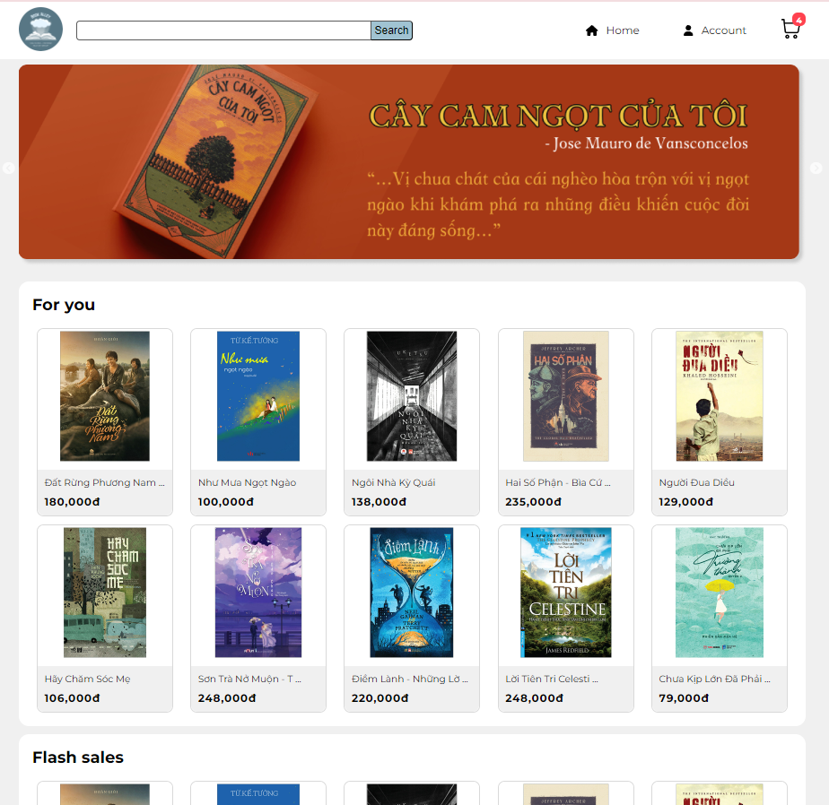

## User Action: Scrolls through the list of available books to explore more.

System Response:

* Detects the user's scrolling behavior and loads additional book listings dynamically to provide a seamless browsing experience.
* Ensures that the book listings are displayed in an engaging and visually appealing manner, using high-quality images and concise descriptions.

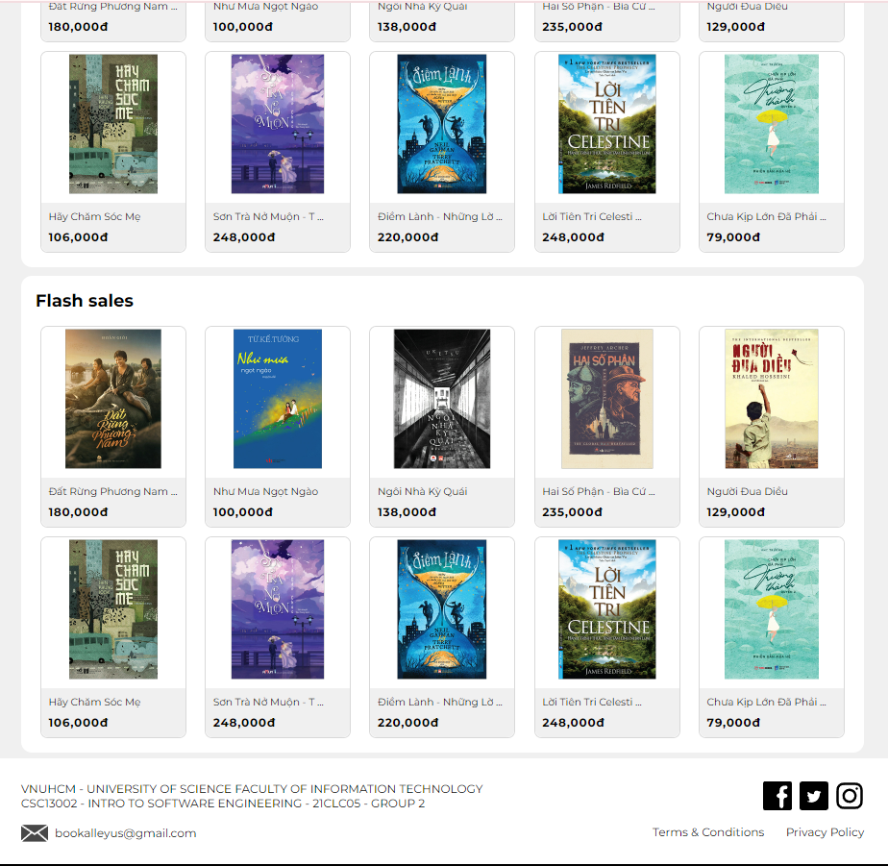

## 

## User action: Selects the account icon to initiate the login process

System response: Presents the login screen with fields for username and password

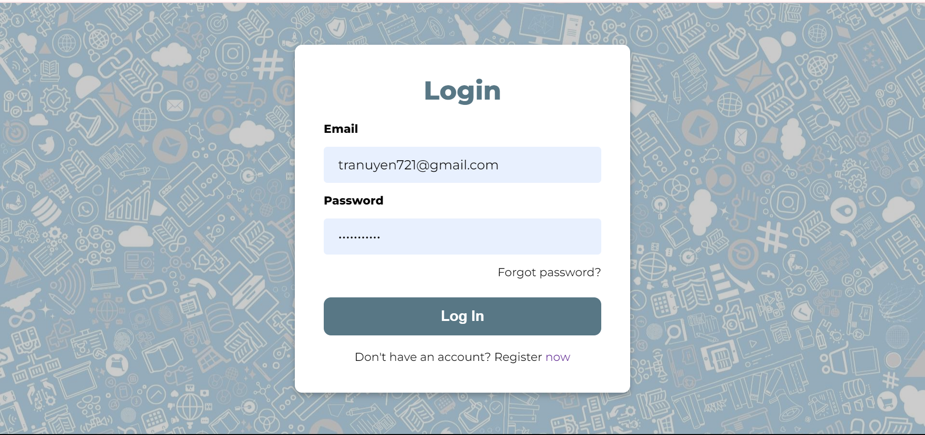

# Logged user - Customer

## User Action: Selects a specific book to view its detail.

System Response:

* Retrieves the detailed information for the selected book from the database, including:
  + Full product description
  + Author biography
  + Customer reviews
  + Availability and pricing information
* Presents the book detail page to the user, providing a comprehensive overview of the selected book.

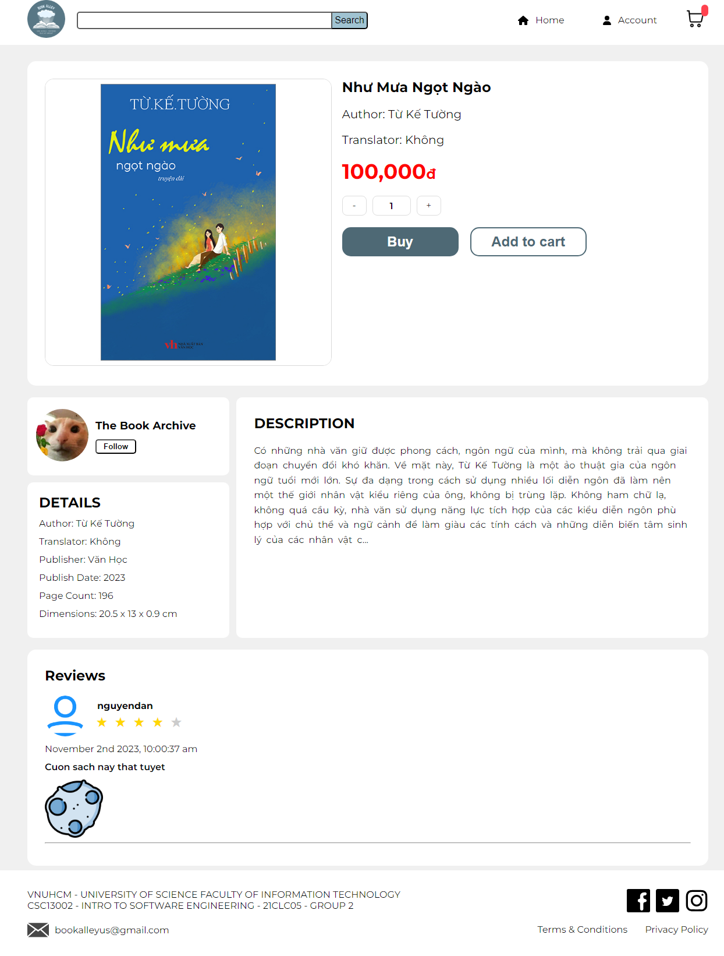

## User Action: Navigates to the shopping cart page to review their selected items and order details.

System Response:

Retrieves the user's cart information from the database and displays it on the shopping cart page.

Presents the user with a summary of their order, including:

* List of items with their titles, quantities, and prices
* Total order amount
* Applicable taxes and shipping charges

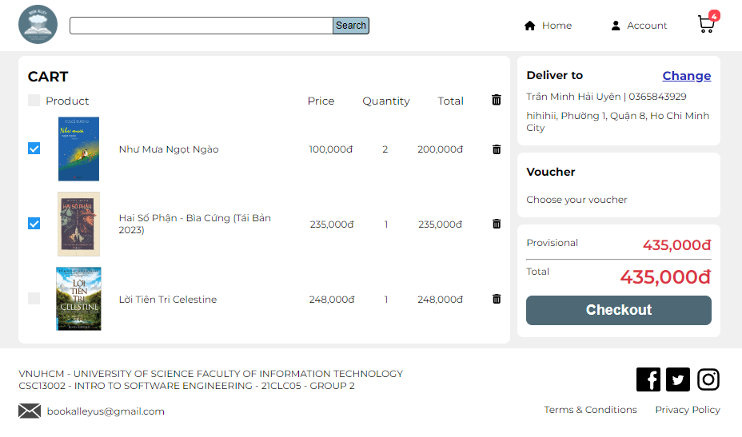

## User Action: Clicks on the "Checkout" button to initiate the checkout process.

System Response:

* Checks if the user is logged in.
* If the user is not logged in: Prompts the user to log in using their existing account or create a new account.
* If the user is already logged in: Proceeds to the next step of the checkout process, display the delivery and payment method.

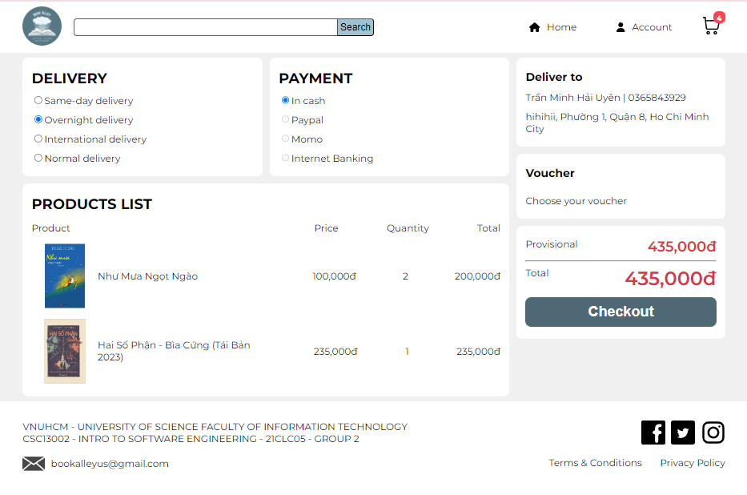

## 

## User action: Navigates to the account icon on the top right corner and selects "My orders" from the dropdown menu.

System response: Displays the user's ordering history, include the books’ title and the total price of the order

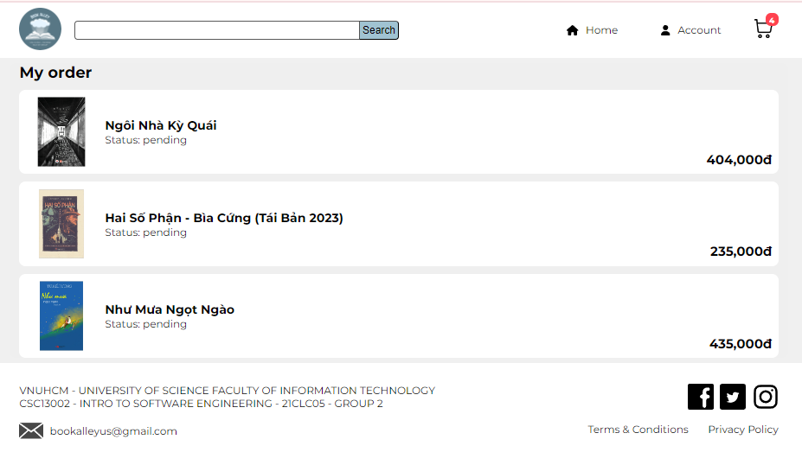

## 

## User action: Navigates to the account icon on the top right corner and selects "Profile" from the dropdown menu.

System response: Displays the user's profile page with options for managing their account information.

